INDUSTRIAL NETWORK

Report


Submitted by
Sher Ali
25112

Department of Computer Science,
Riphah International University, Lahore Campus.

[20/1/2023]

- Introduction
In today's fast-paced business environment, having a reliable and efficient network is crucial for any industry. A network allows for seamless communication and collaboration among different departments, improves productivity and efficiency, and allows for better data management and security. In this industry computer network on Cisco Packet Tracer, we will be simulating a network that connects four departments: manufacturing, supply chain, IT and Human Resources. The network will be designed using Cisco routers and switches, ensuring the security and scalability of the network. This simulation will demonstrate the importance and benefits of having a well-designed and implemented network in an industry setting.
- Objective
The objectives of this industry computer network on Cisco Packet Tracer are as follows:

To connect the four departments (manufacturing, supply chain, IT and Human Resources) within the industry and facilitate communication and collaboration among them.To improve the efficiency and productivity of the network by implementing Quality of Service (QoS) and load balancing techniques.To provide remote access to the network for employees working remotely or from different locations.To simulate and test the network in a controlled environment before deploying it in a real-world setting.To demonstrate the importance and benefits of having a well-designed and implemented network in an industry setting.
- Problem Description
The company is facing several challenges with their current network infrastructure. The different departments are not connected effectively and have limited communication and collaboration among them. This is leading to delays and inefficiencies in the work process. Additionally, the current network lacks proper security measures, leaving it vulnerable to cyber threats. Remote access to the network is also an issue for employees working remotely or from different locations. The company is also facing challenges with managing the network's performance and scalability. This is impacting their ability to keep up with the growing demands of their customers and the industry. The company is now looking for a solution to improve the performance, security, and connectivity of their network to meet their business needs and stay competitive in the industry.
- Requirements
All the requirements related to your system should be listed here.
  - Servers
    - Web Server
    - DHCP server
    - TFTP Server
    - Data Server
  - PCs
  - Laptops
  - Connectivity by
    - Routers
    - Switches

5) Design
The design of this industry computer network on Cisco Packet Tracer is as follows:

We will be using Cisco routers and switches to connect the different departments: manufacturing, supply chain, IT and Human Resources.We will be implementing VLANs to separate the different departments and improve security.Access control will be put in place, such as user authentication, to allow only authorized users access to the network.Quality of Service (QoS) will be implemented to ensure that important network traffic is given priority over less important traffic.Remote access will be provided by using VPN, so employees can connect to the network from outside of the office.Firewall will be put in place to protect the network from external threats.We will be using Cisco Packet Tracer to simulate and test the network before it is deployed in a real-world setting.

6) Implementations Detail
Total Servers=5
Total Routers=23
Total Switches=17
Total PCs and Laptops=40
Departments=4

7)IP addresses;
126.0.0.1 To onwards for devices
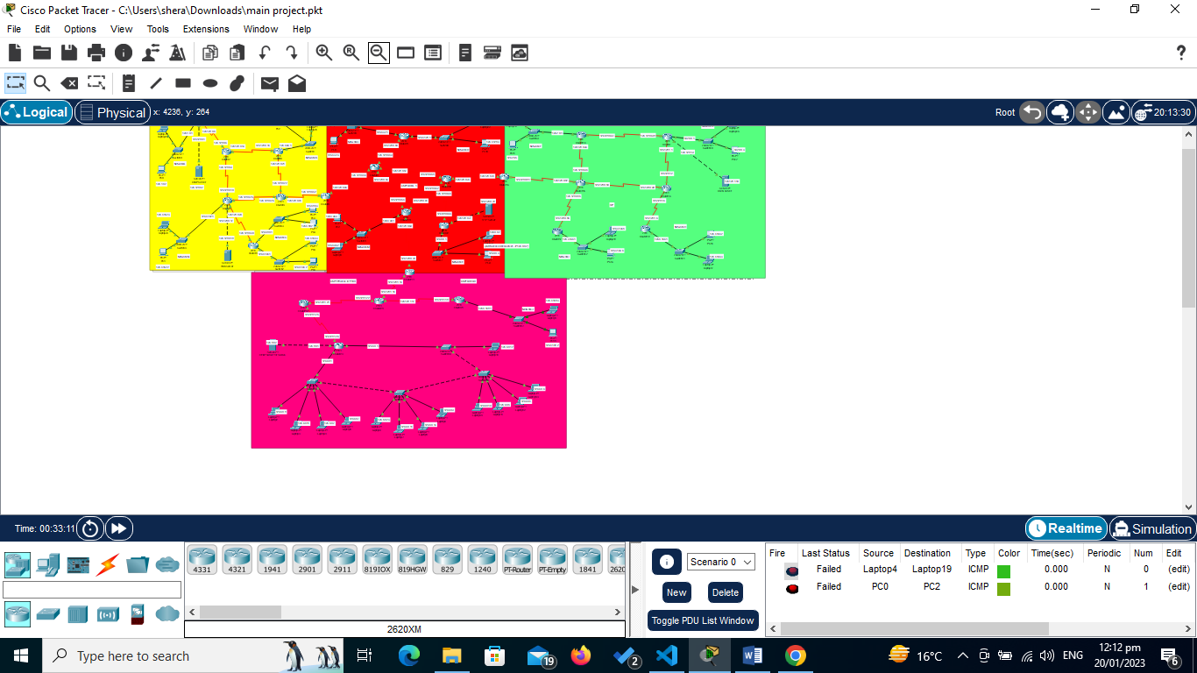
126.128.0.0 To onwards for routers

